Project title: Java Collection Framework Explorer: Implementation of Interfaces and Methods.
1. Aim
To implement and demonstrate the methods of the Java Collection Framework interfaces, including Collection, List, Set, SortedSet, NavigableSet, Queue, Deque, Map, SortedMap, and Iterator.
2. System Requirements
- Language: Java
- JDK: Java 8 or above
- Platform: Online Java compiler, Eclipse, or IntelliJ IDEA
- Hardware: Minimum 4 GB RAM
3. Algorithm
- Start the program.
- Create collection objects using appropriate implementation classes.
- Demonstrate adding, removing, searching, and displaying elements.
- Use List to access elements by index.
- Use Set to eliminate duplicate elements.
- Use SortedSet and NavigableSet to sort and navigate elements.
- Use Queue and Deque to insert and remove elements.
- Use Map and SortedMap to store key-value pairs.
- Use Iterator to traverse collection elements.
- Display the results and stop the program.
4. UML Diagram
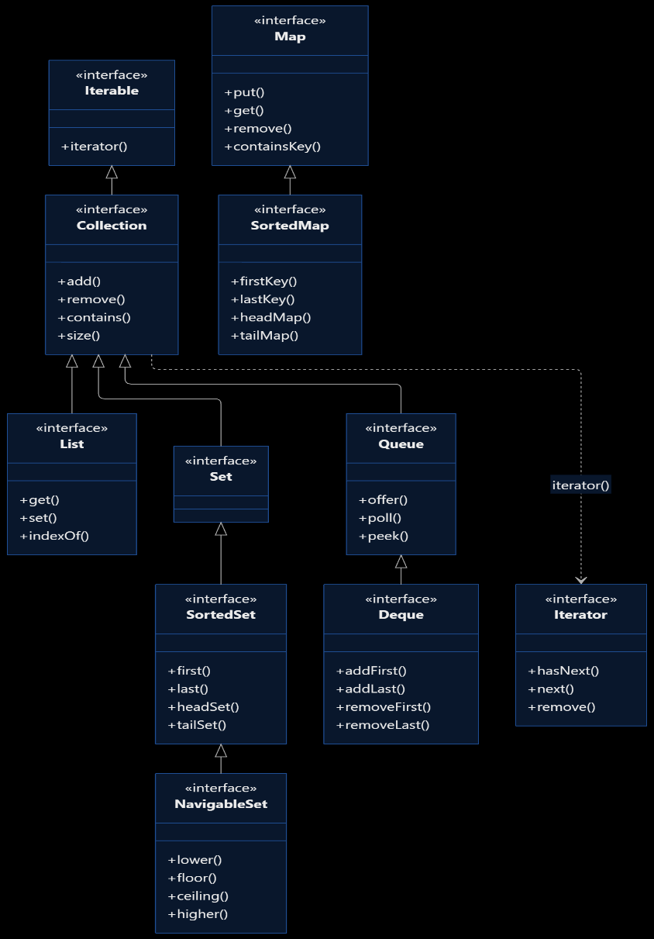
5. source code

import java.util.*;

public class Main {
public static void main(String[] args) {

// 1. Collection Interface
System.out.println("1. COLLECTION INTERFACE");
Collection<String> c = new ArrayList<>();
c.add("Java");
c.add("Python");
c.add("C++");
System.out.println("Collection: " + c);
System.out.println("Contains Java: " + c.contains("Java"));
c.remove("C++");
System.out.println("After removal: " + c);
System.out.println("Size: " + c.size());

// 2. List Interface
System.out.println("\n2. LIST INTERFACE");
List<Integer> list = new ArrayList<>();
list.add(10);
list.add(20);
list.add(30);
list.add(1, 15);
System.out.println("List: " + list);
System.out.println("Element at index 2: " + list.get(2));
list.set(0, 5);
System.out.println("After set: " + list);
list.remove(Integer.valueOf(30));
System.out.println("After removal: " + list);

// 3. Set Interface
System.out.println("\n3. SET INTERFACE");
Set<Integer> set = new HashSet<>();
set.add(10);
set.add(20);
set.add(10);
set.add(30);
System.out.println("Set: " + set);
System.out.println("Contains 20: " + set.contains(20));
set.remove(30);
System.out.println("After removal: " + set);

// 4. SortedSet Interface
System.out.println("\n4. SORTED SET INTERFACE");
SortedSet<Integer> ss = new TreeSet<>();
ss.add(40);
ss.add(10);
ss.add(30);
ss.add(20);
System.out.println("Sorted Set: " + ss);
System.out.println("First: " + ss.first());
System.out.println("Last: " + ss.last());
System.out.println("Head Set (<30): " + ss.headSet(30));
System.out.println("Tail Set (>=20): " + ss.tailSet(20));

// 5. NavigableSet Interface
System.out.println("\n5. NAVIGABLE SET INTERFACE");
NavigableSet<Integer> ns = new TreeSet<>(ss);
System.out.println("Navigable Set: " + ns);
System.out.println("Lower than 30: " + ns.lower(30));
System.out.println("Floor of 30: " + ns.floor(30));
System.out.println("Ceiling of 25: " + ns.ceiling(25));
System.out.println("Higher than 30: " + ns.higher(30));
System.out.println("Descending Set: " + ns.descendingSet());

// 6. Queue Interface
System.out.println("\n6. QUEUE INTERFACE");
Queue<String> queue = new LinkedList<>();
queue.offer("A");
queue.offer("B");
queue.offer("C");
System.out.println("Queue: " + queue);
System.out.println("Peek: " + queue.peek());
System.out.println("Poll: " + queue.poll());
System.out.println("After poll: " + queue);

// 7. Deque Interface
System.out.println("\n7. DEQUE INTERFACE");
Deque<String> deque = new ArrayDeque<>();
deque.addFirst("B");
deque.addFirst("A");
deque.addLast("C");
System.out.println("Deque: " + deque);
System.out.println("Remove First: " + deque.removeFirst());
System.out.println("Remove Last: " + deque.removeLast());
System.out.println("Final Deque: " + deque);

// 8. Map Interface
System.out.println("\n8. MAP INTERFACE");
Map<Integer, String> map = new HashMap<>();
map.put(1, "Apple");
map.put(2, "Banana");
map.put(3, "Mango");
System.out.println("Map: " + map);
System.out.println("Value for key 2: " + map.get(2));
System.out.println("Contains key 1: " + map.containsKey(1));
map.remove(3);
System.out.println("After removal: " + map);

// 9. SortedMap Interface
System.out.println("\n9. SORTED MAP INTERFACE");
SortedMap<Integer, String> sm = new TreeMap<>();
sm.put(30, "C");
sm.put(10, "A");
sm.put(20, "B");
System.out.println("Sorted Map: " + sm);
System.out.println("First Key: " + sm.firstKey());
System.out.println("Last Key: " + sm.lastKey());
System.out.println("Head Map (<30): " + sm.headMap(30));
System.out.println("Tail Map (>=20): " + sm.tailMap(20));

// 10. Iterator Interface
System.out.println("\n10. ITERATOR INTERFACE");
List<String> names = new ArrayList<>();
names.add("Ravi");
names.add("Priya");
names.add("Arun");

Iterator<String> it = names.iterator();
System.out.println("Elements using Iterator:");
while (it.hasNext()) {
System.out.println(it.next());
}

System.out.println("\nAll collection methods executed.");
}
}
6.compilation and execution
java Main.java
java Main
7.expected output

1. COLLECTION INTERFACE
Collection: [Java, Python, C++]
Contains Java: true
After removal: [Java, Python]
Size: 2

2. LIST INTERFACE
List: [10, 15, 20, 30]
Element at index 2: 20
After set: [5, 15, 20, 30]
After removal: [5, 15, 20]

3. SET INTERFACE
Contains 20: true
After removal: [10, 20]

4. SORTED SET INTERFACE
Sorted Set: [10, 20, 30, 40]
First: 10
Last: 40
Head Set (<30): [10, 20]
Tail Set (>=20): [20, 30, 40]

5. NAVIGABLE SET INTERFACE
Lower than 30: 20
Floor of 30: 30
Ceiling of 25: 30
Higher than 30: 40
Descending Set: [40, 30, 20, 10]

6. QUEUE INTERFACE
Queue: [A, B, C]
Peek: A
Poll: A
After poll: [B, C]

7. DEQUE INTERFACE
Deque: [A, B, C]
Remove First: A
Remove Last: C
Final Deque: [B]

8. MAP INTERFACE
Value for key 2: Banana
Contains key 1: true
After removal: {1=Apple, 2=Banana}

9. SORTED MAP INTERFACE
Sorted Map: {10=A, 20=B, 30=C}
First Key: 10
Last Key: 30

10. ITERATOR INTERFACE
Elements using Iterator:
Ravi
Priya
Arun

All collection methods executed.
8. output
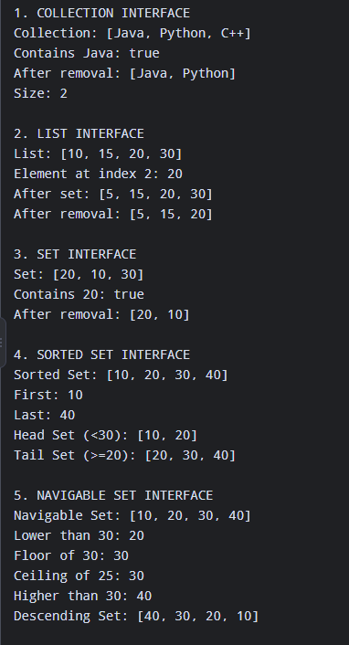
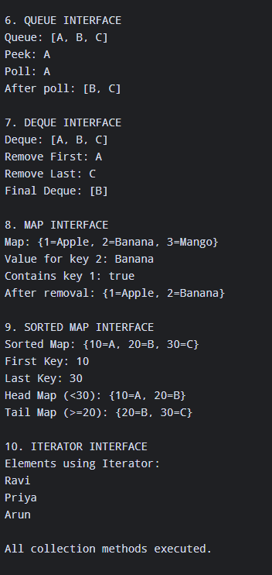
Result
Thus, the Java Collection Framework interfaces and their methods were implemented and executed successfully using appropriate implementation classes.

